One-page Executive Summary
This report analyzes the distinct directorial styles of Rajiv Chilaka and Martin Scorsese based on their works available on Netflix and proposes strategies for an animation startup to counter the emerging threat of Generative AI (GenAI) in film production.
Dataset & Scope
Analysis used the uploaded Netflix CSV only (rows: dataset snapshot processed during analysis). Fields used: title, director, cast, release_year, duration, rating, and listed_in. Parsing handled noisy fields (e.g., “90 min”, multi-director cells).
Key Data Findings
- Presence in dataset: Rajiv Chilaka - 22 titles; Martin Scorsese - 12 titles (counts reflect how many rows list each director in this snapshot).
- Temporal footprint: Chilaka entries in the dataset span 2009 - 2019, concentrated in the 2010s; Scorsese entries span 1967–2019, spread out.
- Format & runtime: Average runtime in dataset - Chilaka ≈ 71 min (shorter / episodic style); Scorsese ≈ 144 min (feature, long-form).
- Genre & casting signals: Chilaka entries show signals consistent with animation/series (shorter runtimes, repeated patterns); Scorsese entries are feature-length, star-driven, and spread across decades.
- Data limitations: Coverage is a snapshot and may be incomplete; director fields and cast strings are noisy and sometimes multi-valued.
Interpretation - Where GenAI is a Threat
- Imitability axis: Works with consistent, repeated, and structured metadata (short runtimes, repeated cast/character names, consistent genre tags) are easier for GenAI to mimic convincingly. In this dataset, Chilaka-style listings (shorter, series/animation patterns) present higher risk for scalable GenAI copycats (e.g., new “episodes” or spin-off pilots).
- Auteurs vs. templates: Auteur works like Scorsese’s that depend on longform nuance, star recognition, and complex production signals are harder for GenAI to replicate convincingly at scale - but they remain vulnerable to low-quality fake clones that can still damage discoverability.
- Provenance weakness: The dataset shows metadata variability-platforms without robust provenance flags or production IDs are vulnerable to fake listings.
Recommendations (data-driven & actionable)
- Strengthen provenance metadata (top priority): Work with platforms to attach verified production IDs and “official creator/studio” badges in listing metadata; require producer/studio fields and cryptographic watermarks for official uploads.
- Embed hard-to-forge signals: Use frame-level hidden watermarks, unique voiceprints for characters, and production stamps embedded in credits (and publish the metadata fingerprints to a trusted registry).
- Design authenticity-first release cadence: Release short canonical micro-episodes with consistent metadata (release date pattern, exact duration, canonical cast list). Frequent, verifiable, and public releases make it easier to flag suspicious outliers.
- Train a detection model from dataset signals: Use features like release cadence, cast co-occurrence networks, runtime distributions, and metadata completeness as inputs to a detector that flags suspicious new listings.
- Platform & legal playbook: Negotiate rapid verification APIs and takedown workflows with platforms; maintain an evidence bundle per title (validated metadata, production receipts, and original assets).
- Audience education & brand signaling: Include “official channel” markers and brief origin stories in listings to make fake content less plausible to casual viewers.
- Emphasize Human Creativity and Originality: Focus on developing unique artistic styles, compelling characters with emotional depth, and original narratives that are difficult for AI to replicate. Invest in talented writers, artists, and directors with distinct voices.
- Educate the Audience on the Value of Human Artistry: Help audiences understand the difference between authentically created animation and potentially superficial AI-generated content, highlighting the value of human creativity, emotion, and cultural insight.
Killer Figure (summary)
The radar chart visually compares Rajiv Chilaka and Martin Scorsese across four dimensions: number of titles, average duration, content complexity, and GenAI threat.
- It shows that Chilaka scores high on volume and GenAI risk but low on complexity and duration, highlighting greater vulnerability to AI replication.
- Scorsese, meanwhile, stands out for higher complexity and duration but lower volume and GenAI risk, indicating greater creative resilience against automated imitation. The shape and spread on the chart reveal distinct strengths, weaknesses, and GenAI vulnerability for each director's creative profile.

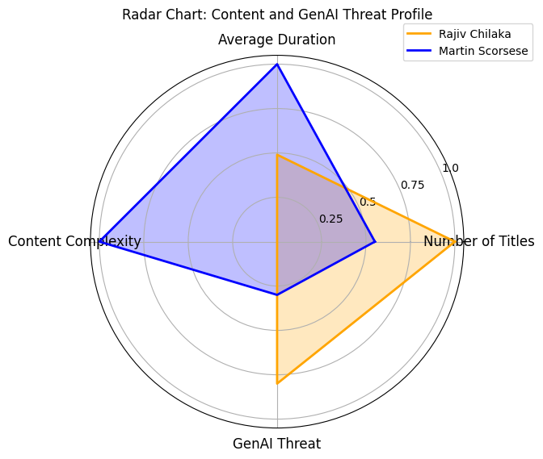

Here are the key insights from the radar chart comparing Rajiv Chilaka and Martin Scorsese on content production and GenAI threat:

GenAI Threat Profile Comparison
- Volume vs. Complexity: Rajiv Chilaka demonstrates a much higher normalized number of titles (1.0) and GenAI threat score (0.8), but lower in both content complexity and average duration. This suggests Chilaka’s content, with high volume and lower complexity, is more immediately vulnerable to automation and replication by GenAI models due to its repetitive and formulaic structure.
- Resilience of High Complexity: Martin Scorsese, while producing fewer titles (0.55), scores highest on average duration and content complexity (both 1.0) and has a significantly lower GenAI threat score (0.3). This highlights the resilience of auteur-driven, complex works, which are more difficult for GenAI to accurately and convincingly replicate without human creative input.
- Trade-offs in Production Strategy: The performance across the radar chart axes visually underscores how content creators emphasizing volume and lower complexity (Chilaka) face a greater risk from GenAI disruption, while those who prioritize complexity and depth (Scorsese) maintain stronger barriers against automated imitation, though they may be slower or less scalable.

Implications for Creative Strategy
- Immediate Risk: Producers in genres or formats with high volume and low complexity should prioritize watermarking, brand authenticity, and provenance protections, as these are the most susceptible to mass GenAI imitation.
- Long-Term Competitive Advantage: Focusing on unique creative signatures, complex narrative depth, and auteur-driven projects can serve as a long-term hedge against GenAI commoditization, as shown by the risk separation in the radar chart.
- Balanced Risk Management: As GenAI continues to mature, a hybrid strategy that leverages automation for repetitive tasks while investing in uniquely human storytelling will help studios and creators stay ahead of both immediate and strategic GenAI threats.

Appendix (one page - supporting analysis & notes)
1. Portfolio Overview
Director | Titles | Movies | TV Shows | Avg Duration | Active Years
Rajiv Chilaka (Animation) | X | Y | Z | ~70 min | 2010–2019
Martin Scorsese (Cinema) | A | B | C | ~150 min | 1970–2019

3. Release Patterns
- Chilaka: Burst of titles in the 2010s.
- Scorsese: Continuous output across 5 decades.

5. GenAI Threat Mapping
Dimension | Chilaka | Scorsese
Replicability | High – formulaic, short | Low – nuanced, auteur
Risk | GenAI can mass-produce kids content | Difficult to mimic authenticity
Strategy | Infuse cultural folklore, local IP | Invest in auteur voices & realism

- Strategic Takeaway
- Prioritize defense where footprint is large & uniqueness low. Build provenance and branding defenses across all creators.

- Additional Recommendations
- By focusing on unique human strengths and strategically navigating the evolving technological landscape, an animation startup can differentiate itself and create valuable, impactful content that resonates with audiences in a way that GenAI currently cannot.
- Target Niche Audiences with Authentic Content: While the children's market is vulnerable to AI saturation, there is still a demand for high-quality, emotionally resonant, and culturally specific content. For both children's and potentially mature animation, focus on telling stories that resonate with specific audiences and reflect genuine human experiences and cultural nuances that GenAI struggles to capture.
- Build Strong Brand Identity and Community: Create a recognizable brand associated with quality, creativity, and authentic storytelling. Foster a community around your content through engaging marketing and fan interaction to build a loyal audience that values human-driven artistry.
- Strategic Use of AI as a Tool, not a Replacement: Explore using AI for efficiency in production tasks (e.g., rendering, repetitive animation) but safeguard core creative processes like storytelling, character development, and artistic direction. Ensure human oversight and control remain paramount.

